**Project Milestone 1**



**Spring 2025**

**Group Members**

|  |  |
| --- | --- |
| **Name** | **Registration Number** |
| Hassan Zaib Jadoon | 22PWCSE2144 |
| Ahsan Raza | 22PWCSE2099 |
| Mutahhar Fayyaz | 22PWCSE2176 |

“On my honor, as student of University of Engineering and Technology, I have neither given nor received unauthorized assistance on this academic work.”

Submitted to:

**Engr. Summeyea Salahuddin**

Department of Computer Systems Engineering

**University of Engineering and Technology, Peshawar**

**Database Design**

**Conceptual Design**

The database design follows a normalized approach ensuring data integrity, reducing redundancy, and maintaining referential consistency. The schema supports complex relationships between entities while maintaining performance.

**Entity Relationship Diagram**

|  |  |  |  |  |
| --- | --- | --- | --- | --- |
| **Entity Name** | **Attributes** | **Primary Key** | **Foreign Key(s)** | **Relationship Types** |
| **Users** | id, name, email, password, created_at | id | - | **Disjoint specialization** with Admins and Normal Users |
| **Admins** | id, name, email, password, created_at | id | - | **One-to-Many** with Events |
| **Events** | id, admin_id, title, description, date, time, venue, available_seats, price, created_at | id | admin_id → Admins(id) | **Many-to-One** with Admins, **One-to-Many** with Bookings, **One-to-Many** with Seats |
| **Bookings** | id, event_id, customer_name, customer_email, customer_phone, status, booking_date | id | event_id → Events(id) | **Many-to-One** with Events, **Many-to-Many** with Seats (via Booking_Seats) |
| **Seats** | id, event_id, seat_number, section, price, status, created_at | id | event_id → Events(id) | **Many-to-One** with Events, **Many-to-Many** with Bookings (via Booking_Seats) |
| **Booking_Seats** | id, booking_id, seat_id, booking_date, created_at | id | booking_id → Bookings(id), seat_id → Seats(id) | **Many-to-One** with Bookings, **Many-to-One** with Seats |

**Important Notes:**

1. **Disjoint Relationship**: The Users entity has a **disjoint specialization** where users are categorized as either:
   * **Admin Users**: Have administrative privileges to manage events
   * **Normal Users**: Regular users who can book events

This means a user cannot be both an admin and a normal user simultaneously - they must be one or the other.

**Detailed Relationship Analysis:**

**Specialization Relationships:**

* **Users ↔ Admins/Normal Users**: **Disjoint Specialization** (ISA relationship)
  + A user can be either an Admin OR a Normal User, but not both

**Binary Relationships:**

1. **Admins ↔ Events**: **One-to-Many** (1:M)
   * One Admin can manage multiple Events
   * Each Event is managed by exactly one Admin
2. **Events ↔ Bookings**: **One-to-Many** (1:M)
   * One Event can have multiple Bookings
   * Each Booking is for exactly one Event
3. **Events ↔ Seats**: **One-to-Many** (1:M)
   * One Event can have multiple Seats
   * Each Seat belongs to exactly one Event
4. **Bookings ↔ Seats**: **Many-to-Many** (M:N)
   * One Booking can reserve multiple Seats
   * One Seat can be part of multiple Bookings (over time, but only one active booking)
   * Resolved through **Booking_Seats** junction table

**Ternary Relationships:**

* **Booking_Seats** acts as a **junction entity** resolving the Many-to-Many relationship between Bookings and Seats

**Cardinality Summary:**

* **Admin : Events** = 1:M
* **Event : Bookings** = 1:M
* **Event : Seats** = 1:M
* **Booking : Seats** = M:N (via Booking_Seats)

**Finalized Conceptual Schema**

**Entity Relationship Diagram (ERD)**:

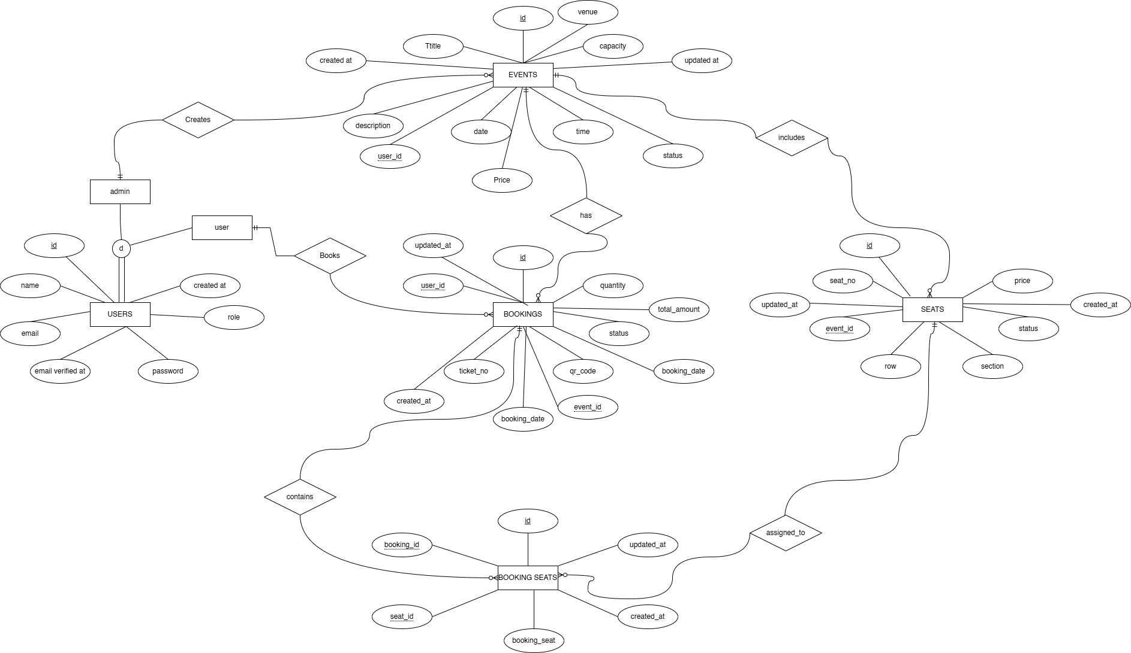

**Enhanced ERD:**

EERD includes additional attributes and relationships such as event ownership and booking status.

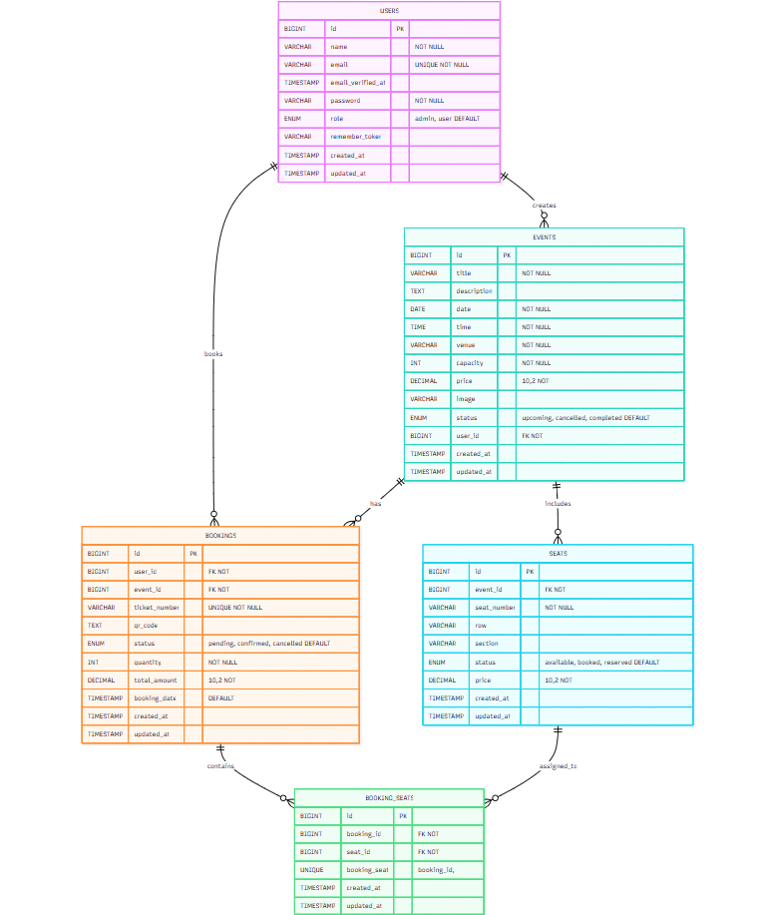

**Business Rules:**

* An admin can create multiple events.
* Each event is created and managed by one admin only.
* A customer can book a seat for an event without creating a user account.
* Each booking must be linked to one event.
* Each event must have a valid title, date, time, venue, capacity, and price before being listed.
* Events must have a status of either active, inactive, or cancelled. Only active events can be booked.
* The system must not allow seat capacity to be negative.
* Once all seats are booked or reserved, no new bookings can be made.
* Each seat is unique per event, identified by seat number.
* Seats must be marked as available, booked, or reserved. Booked seats cannot be double-booked.
* Each booking must generate a unique ticket number and QR code.
* The total amount for a booking is calculated based on the number of selected seats and seat price.
* Admins can edit or delete any event they created.
* When an event is deleted, all associated seats and bookings are also deleted.
* The system stores customer details such as name, email, and phone for every booking.
* A booking must include at least one seat.
* Only bookings with pending or confirmed status are considered active. Cancelled bookings release their seats.
* A user with role 'admin' can manage events. A user with role 'user' can only book events.
* Seats can have custom prices. If not set, the default event price is used.

# References

1. Lecture Slides (Lecture 2 & Lecture 3) - Database Design

2. draw.io - for drawing ERD and EERD diagrams (https://draw.io)

3. ChatGPT by OpenAI - for code generation and documentation structure (https://chat.openai.com)

4. W3Schools - for syntax reference (https://www.w3schools.com/sql/)

5. MySQL Official Docs - https://dev.mysql.com/doc/